.NET PRACTICALS

VVPEC CE | SEM-6

DIVYA DORI

160470107015

2019

Contents

AIM : Introduction to c# 1

Program 1 1

AIM: Inheritance 10

Program 1 10

Program 2 11

Program 3 13

Program 4 15

AIM: Method & constructor overloading 18

Program 1 18

Program 2 22

AIM: Reflection 25

Program 1 25

AIM: Files Operations 29

Program 1 29

Program 2 31

AIM: Database Connectivity 34

Program 1 34

AIM: form validation 51

Program 1 51

AIM: master page 54

Program 1 54

AIM: web services 58

Program 1 58

**Practical 1**

# AIM : Introduction to c#

## Program 1

Variables:

Initialization

Scope

Constant

Predefined Data Types

Value Types

Reference TYpes

Flow Control

Conditional Statements(if, switch)

Loop(for, while, dowhile, foreach)

Jump(goto, break, continue, return)

Eumerations

Passing Arguments

using System;

using System.Collections.Generic;

using System.Linq;

using System.Text;

using System.Threading.Tasks;

namespace aim

{

class Program

{

static int newint=100;

public enum TimeOfDay

{

Morning = 0,

Afternoon = 1,

Evening = 2

}

public static void Main(string[] args)

{

Console.WriteLine("\n integer types");

sbyte sb = 10;

short s = 33;

int i = 10;

long l = 33L;

byte b = 22;

ushort us = 33;

uint ul = 33u;

ulong ulo = 33ul;

Console.WriteLine("{0},{1},{2},{3},{4},{5},{6},{7}", sb, s, i, l, b, us, ul, ulo);

float f = 1.122345656767f;

double d = 12.1234455657878797;

Console.Write("\nFloat and Double:\n");

Console.WriteLine("{0} and \n{1}", f, d);

decimal dec=111.666666666666666666666M;

Console.WriteLine("decimal:\n{0} ",dec);

Console.WriteLine("\nBoolean:");

bool boolean =true;

Console.WriteLine("Status: " + boolean);

// Console.ReadLine();

char character ='d';

Console.WriteLine(character);

character = '\0';

Console.WriteLine("Now null: " + character);

object o1 = "Hi, I am ALICE";

object o2 = 15.3454365;

string strObj = o1 as string;

Console.WriteLine(strObj);

Console.WriteLine(o1.GetHashCode() + " " + o1.GetType());

Console.WriteLine(o2.GetHashCode() + " " + o2.GetType());

Console.WriteLine(o1.Equals(o2));

string s1, s2;

s1 = "this is string";

s2 = s1;

Console.WriteLine("S1 is: {0} and s2 is {1}", s1, s2);

s2 = "other string";

Console.WriteLine("S1 is: {0} and s2 is {1}", s1, s2);

s1 = "c:C:\\Users\\Dell\\source\\repos\\aim";

Console.WriteLine(s1);

s1 = @"c:C:\Users\Dell\source\repos\aim\aim";

Console.WriteLine(s1);

s1 = @"We can also write

like this";

Console.WriteLine(s1);

bool isZero;

Console.WriteLine("\nFlow Control: (if)\ni is " + i);

if (i == 10)

{

isZero = true;

Console.WriteLine("i is Zero {0}",isZero);

}

else

{

isZero = false;

Console.WriteLine("i is Non - zero");

}

int integerA = 1;

Console.WriteLine("\nSwitch:");

switch (integerA)

{

case 1:

Console.WriteLine("integerA = 1");

break;

case 2:

Console.WriteLine("integerA = 2");

//goto case 3;

break;

case 3:

Console.WriteLine("integerA = 3");

break;

default:

Console.WriteLine("integerA is not 1, 2, or 3");

break;}

WriteGreeting(TimeOfDay.Morning);

Console.WriteLine("Argument is: {0}",args[1]);

void WriteGreeting(TimeOfDay timeOfDay)

{

switch (timeOfDay)

{

case TimeOfDay.Morning:

Console.WriteLine("Good morning!");

break;

case TimeOfDay.Afternoon:

Console.WriteLine("Good afternoon!");

break;

case TimeOfDay.Evening:

Console.WriteLine("Good evening!");

break;

default:

Console.WriteLine("Hello!");

break;

}}

Console.WriteLine("Scope of Variables.\n1:");

int newint=0;

int j;

for (/*int*/ j = 0; j < 2; j++) //removing comment from for loop will raise error

{

//int j;

//uncomment above line to error "A local variable named 'j' cannot be declared in this

//scope because it would give a different meaning to 'j', which is already

//used in a 'parent or current' scope to denote something else"

Console.Write("{0} {1}\n", newint, Program.newint);

}

Console.WriteLine("2:");

for (int k = 0; k < 3; k++)

{

Console.Write("{0} ", k);

}//Scope of k ends here

Console.Write("\n");

//Console.Write(k);

//uncomment above line to see error "The name 'k' does not exist in the current context"

for (int k = 3; k > 0; k--)

{

Console.Write("{0} ", k);

}//scope of k ends here again

Console.WriteLine("Constants");

const int valConst = 100; // This value cannot be changed.

Console.WriteLine("{0} is constant value", valConst);

//valConst = 45;

//uncomment above line to see error "The left-hand side of an assignment must be a variable, property or indexer"

//const only allow constant variables into the expression

const int valConst2 = valConst + 9 /* + j*/;

//remove comments from the above line to see error "The expression being assigned to 'valConst2' must be constant"

Console.WriteLine("Another Constant: {0}", valConst2);

Console.WriteLine("\nPredefined Data Types\n\nValue Types and Reference Types");

//Value Types

int vali = 2, valj = vali;

Console.WriteLine("vali is: {0} and valj is: {1}", vali, valj);

valj = 90;

Console.WriteLine("vali is: {0} and valj is: {1}", vali, valj);

//Referece Types

Vector x, y;

x = new Vector();

x.value = 3;

y = x;

Console.WriteLine("x is: {0} and y is:{1}", x.value, y.value);

y.value = 234;

Console.WriteLine("x is: {0} and y is:{1}", x.value, y.value);

//If a variable is a reference, it is possible to indicate that it does not refer to any object by setting its value to null:

y = null;

//Console.Write("Value for y is: " + y.value);

//uncomment above line to see runtime exception "System.NullReferenceException: Object reference not set to an instance of an object."

//CTS

}

public class Vector

{

public int value;

}

}

}

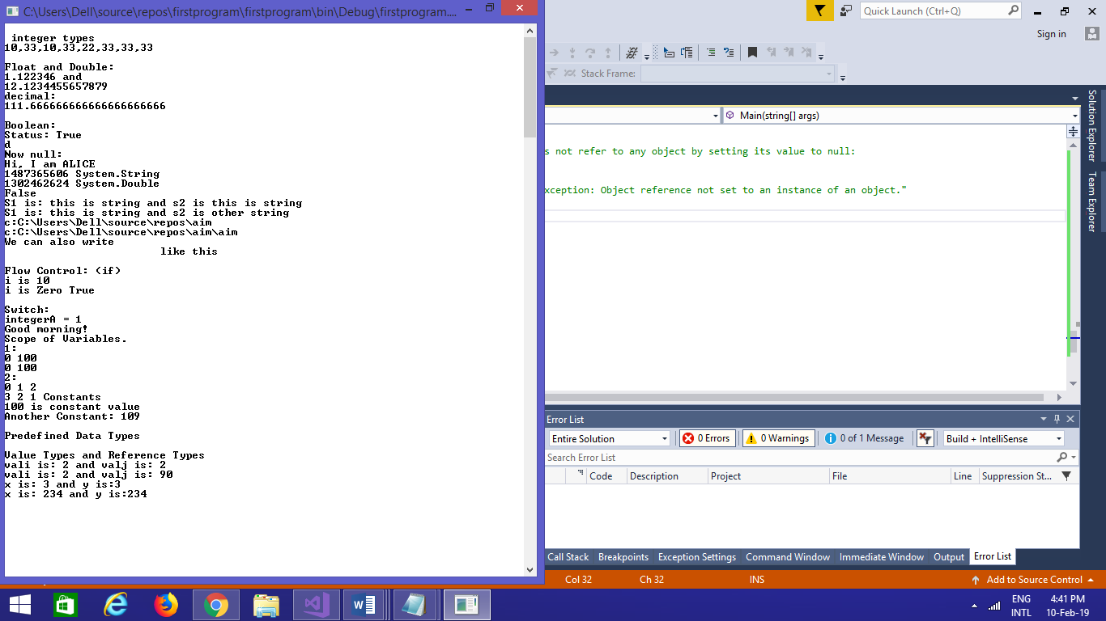

**Practical 2**

# AIM: Inheritance

## Program 1

Perform following programs in c#.

1. Write console based program in code behind language VB or C# to print following pattern.

@ @ @ @ @

@ @ @ @

@ @ @

@ @

@

using System;

using System.Collections.Generic;

using System.Linq;

using System.Text;

using System.Threading.Tasks;

namespace practical2

{

class Program

{

static void Main(string[] args)

{

for(int i=5;i>0;i--)

{

for (int j = i; j > 0; j--)

{

Console.Write("@");

}

Console.WriteLine(" ");

}

Console.ReadKey();

}

}

}

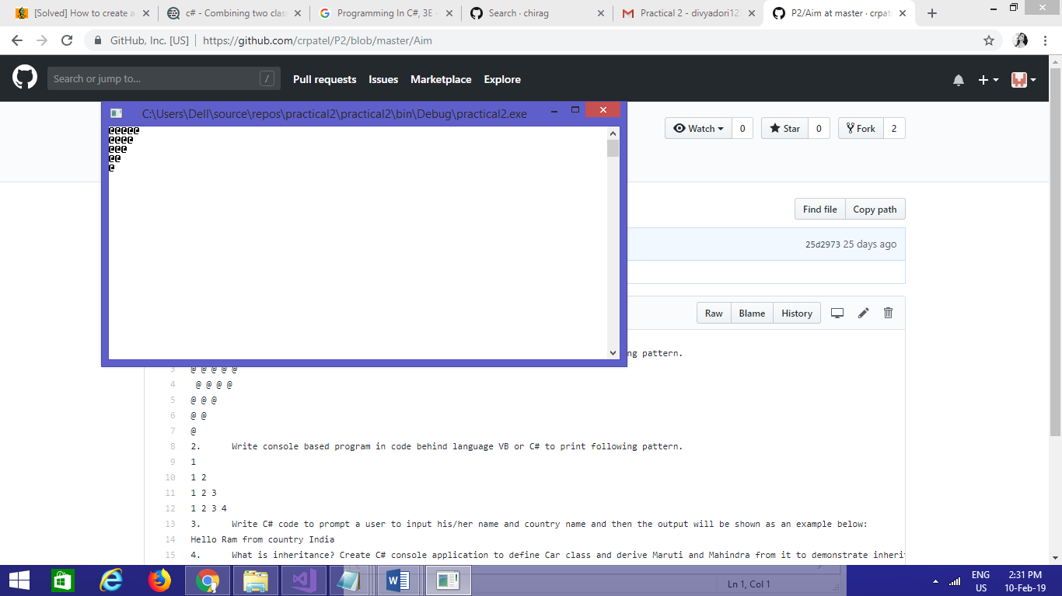

## Program 2

2. Write console based program in code behind language VB or C# to print following pattern.

1

1 2

1 2 3

1 2 3 4

using System;

using System.Collections.Generic;

using System.Linq;

using System.Text;

using System.Threading.Tasks;

namespace practical2._1

{

class Program

{

static void Main(string[] args)

{

for(int i=1;i<=5;i++)

{

for(int j=i;j>0;j--)

{

Console.Write("{0}",i);

}

Console.WriteLine("");

}

Console.ReadKey();

}

}

}

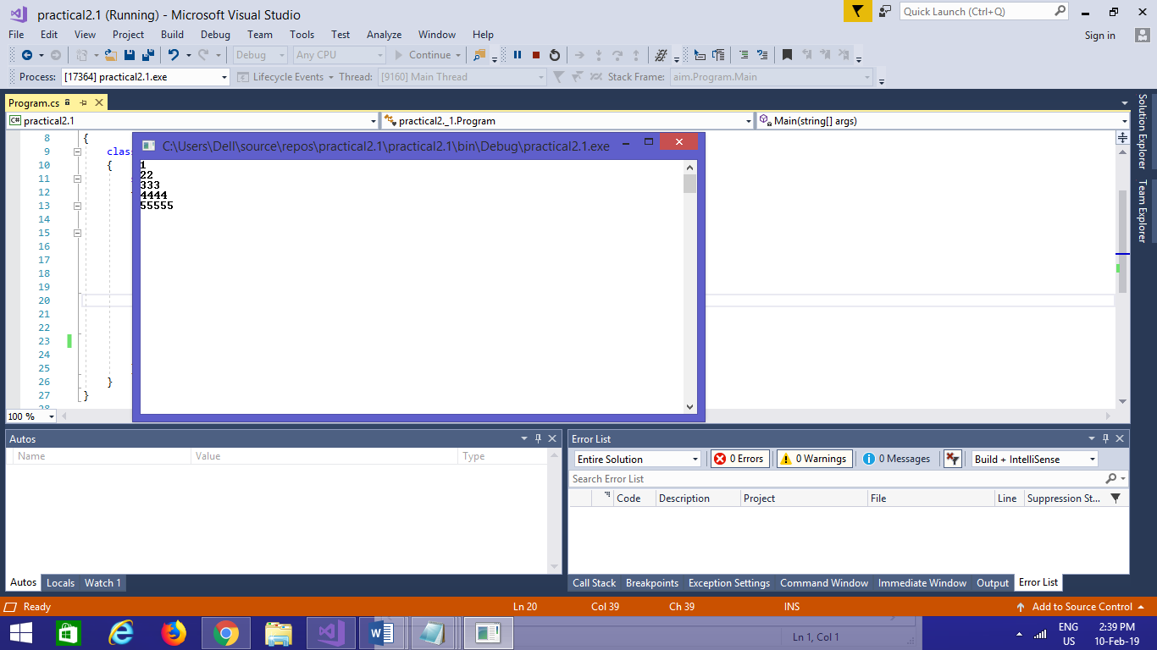

## Program 3

3. Write C# code to prompt a user to input his/her name and country name and then the output will be shown as an example below:

Hello Ram from country India

using System;

using System.Collections.Generic;

using System.Linq;

using System.Text;

using System.Threading.Tasks;

namespace practical2._2

{

class Program

{

static void Main(string[] args)

{

string name;

string country;

Console.WriteLine("enter your name:");

name=Console.ReadLine();

Console.WriteLine("enter your country:");

country = Console.ReadLine();

Console.WriteLine("hello {0} from country {1}",name,country);

Console.ReadKey();

}

}

}

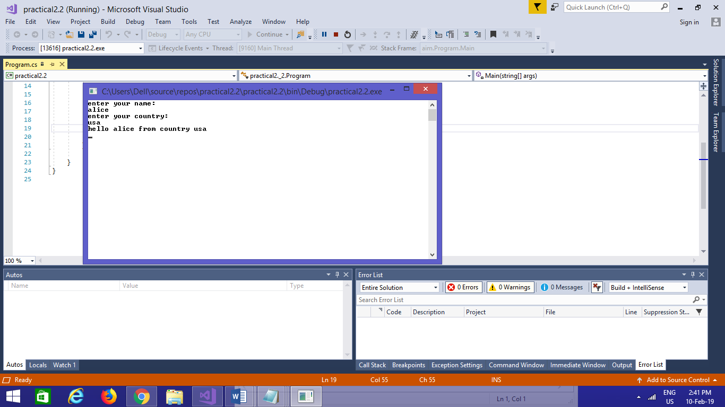

## Program 4

4. What is inheritance? Create C# console application to define Car class and derive Maruti and Mahindra from it to demonstrate inheritance.

using System;

using System.Collections.Generic;

using System.Linq;

using System.Text;

using System.Threading.Tasks;

namespace practical2._3

{

class car

{

public void Method1()

{

Console.WriteLine("this is the method of car class");

}

}

class maruti:car

{

public void method2()

{

Console.WriteLine("this is the method of maruti");

Console.ReadKey();

}

}

class mahindra:car

{

public void method3()

{

Console.WriteLine("this is the method of mahindra");

}

}

class Program

{

static void Main(string[] args)

{

mahindra m = new mahindra();

maruti m1 = new maruti();

m.Method1();

m1.Method1();

Console.ReadKey();

}

}

}

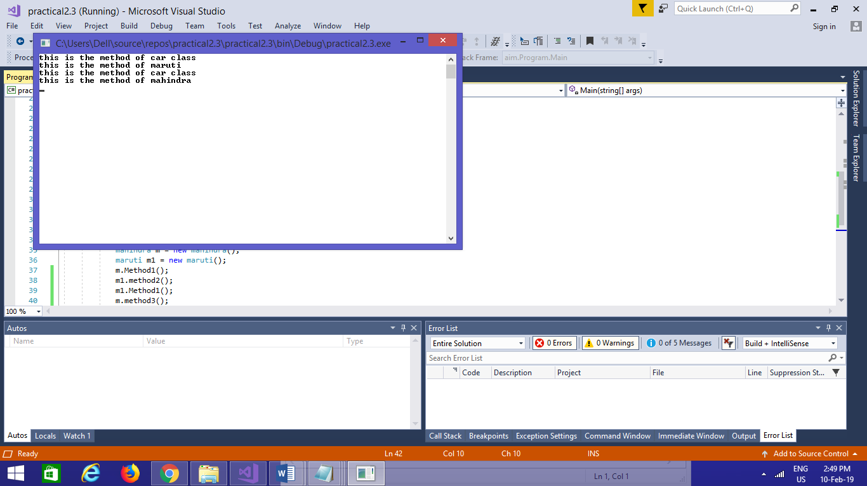

**Practical 3**

# AIM: Method & constructor overloading

## Program 1

Write a c# program to add two integers, two vectors and two metric using method overloading.

using System;

using System.Collections.Generic;

using System.Linq;

using System.Text;

using System.Threading.Tasks;

namespace p3

{

public class Add

{

public void add()

{

int[,] m1 = new int[50, 50];

int[,] m2 = new int[50, 50];

int[,] m3 = new int[50, 50];

Console.WriteLine("enter size of array:");

int size = Convert.ToInt32(Console.ReadLine());

Console.WriteLine("enter first array:");

for (int i = 0; i < size; i++)

{

for (int j = 0; j < size; j++)

{

m1[i, j] = Convert.ToInt32(Console.ReadLine());

}

}

Console.WriteLine("enter second array:");

for (int i = 0; i < size; i++)

{

for (int j = 0; j < size; j++)

{

m2[i, j] = Convert.ToInt32(Console.ReadLine());

}

}

for (int i = 0; i < size; i++)

{

for (int j = 0; j < size; j++)

{

m3[i, j] = m1[i, j] + m2[i, j];

}

}

Console.WriteLine("addition array:");

for (int i = 0; i < size; i++)

{

Console.Write("\n");

for (int j = 0; j < size; j++)

{

Console.Write("{0}\t", m3[i, j]);

}

Console.Write("\n");

}

}

public int add(int a, int b)

{

return (a + b);

}

}

public class Vector

{

public void add()

{

Console.WriteLine("enter first vector");

int x = Convert.ToInt32(Console.ReadLine());

int y = Convert.ToInt32(Console.ReadLine());

int z = Convert.ToInt32(Console.ReadLine());

Console.WriteLine("enter second vector");

int x1 = Convert.ToInt32(Console.ReadLine());

int y1 = Convert.ToInt32(Console.ReadLine());

int z1 = Convert.ToInt32(Console.ReadLine());

int x2 = x + x1;

int y2 = y + y1;

int z2 = z + z1;

Console.WriteLine("<" + x2 + "," + y2 + "," + z2 + ">");

}

}

class Program

{

static void Main(string[] args)

{

Add a1 = new Add();

Vector v1 = new Vector();

v1.add();

a1.add();

int res=a1.add(1, 2);

Console.Write("method overloading for addtion{0}",res);

Console.ReadLine();

}

}

}

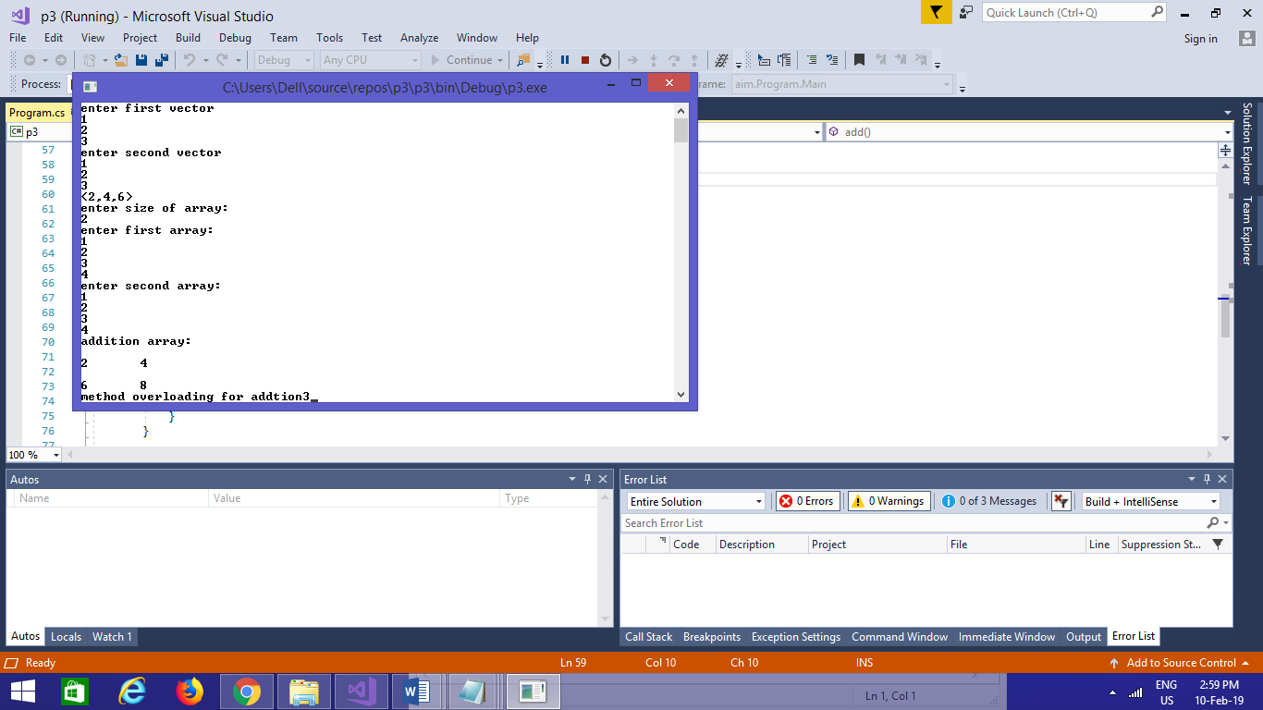

## Program 2

Write a c# program that create student object. Overload constror to create new instant with following details.

1. Name

2. Name, Enrollment

3. Name, Enrollment, Branch

using System;

using System.Collections.Generic;

using System.Linq;

using System.Text;

using System.Threading.Tasks;

using System.Reflection;

namespace p3a1

{

class Program

{

public int ID { get; set; }

public string Name { get; set; }

String name, branch;

int enrol;

public Program(String name)

{

this.name = name;

Console.WriteLine("constructor 1:" + name);

}

public Program(String name, int enrol)

{

this.name = name;

this.enrol = enrol;

Console.WriteLine("constructor 2:" + name + " " + enrol);

}

public Program(String name, int enrol, String branch)

{

this.name = name;

this.enrol = enrol;

this.branch = branch;

Console.WriteLine("constructor 3:" + name + " " + enrol + " " + branch);

}

static void Main(string[] args)

{

Program p1 = new Program("bob");

Program p2 = new Program("bob", 1);

Program p3 = new Program("bob", 1, "computer");

Console.ReadLine();

}

}

}

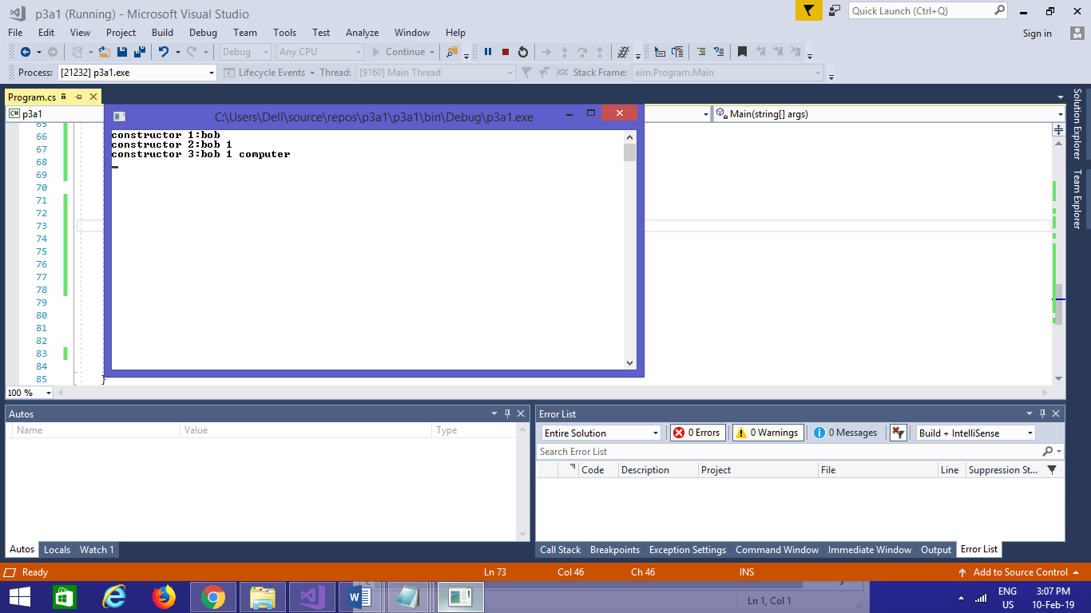

**Practical 4**

# AIM: Reflection

## Program 1

using System;

using System.Collections.Generic;

using System.Linq;

using System.Text;

using System.Threading.Tasks;

using System.Reflection;

namespace p3a1

{

class Program

{

public int ID { get; set; }

public string Name { get; set; }

String name, branch;

int enrol;

public void printID()

{

Console.WriteLine("ID is: {0}", this.ID);

}

public void printName()

{

Console.WriteLine("Name is: {0}", this.Name);

}

public Program(String name)

{

this.name = name;

Console.WriteLine("constructor 1:" + name);

}

public Program(String name, int enrol)

{

this.name = name;

this.enrol = enrol;

Console.WriteLine("constructor 2:" + name + " " + enrol);

}

public Program(String name, int enrol, String branch)

{

this.name = name;

this.enrol = enrol;

this.branch = branch;

Console.WriteLine("constructor 3:" + name + " " + enrol + " " + branch);

}

static void Main(string[] args)

{

try

{

Type T = Type.GetType("p3a1.Program");

MethodInfo[] methods = T.GetMethods();

foreach (MethodInfo method in methods)

{

Console.WriteLine(method.ReturnType + " " + method.Name);

}

PropertyInfo[] properties = T.GetProperties();

Console.WriteLine("\nProperties");

foreach (PropertyInfo property in properties)

{

Console.WriteLine(property.PropertyType + " " + property.Name);

}

Console.WriteLine("\nConstructors");

ConstructorInfo[] constructors = T.GetConstructors();

foreach (ConstructorInfo constructor in constructors)

{

Console.WriteLine(constructor.ToString());

}

Program p1 = new Program("bob");

Program p2 = new Program("bob", 1);

Program p3 = new Program("bob", 1, "computer");

Console.ReadLine();

catch (Exception e)

{

Console.WriteLine(e);

Console.ReadLine();

}

}

}

}

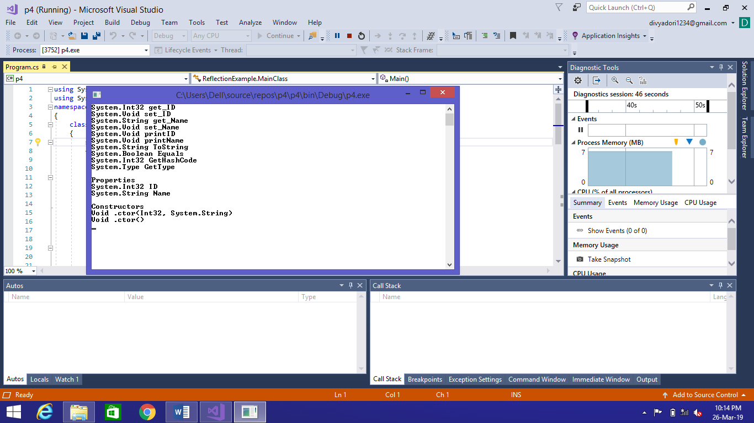

**Practical 5**

# AIM: Files Operations

## Program 1

using System;

using System.Collections.Generic;

using System.Linq;

using System.Text;

using System.Threading.Tasks;

using System.IO;

namespace copyfile

{

class Program

{

public static void Main()

{

CopyFile cp = new CopyFile();

string file1 = @"C:\Users\Dell\source\repos\copyfile\copyfile\bin\Debug\file1.txt";

string file2= @"C:\Users\Dell\source\repos\copyfile\copyfile\bin\Debug\file2.txt";

cp.copyfile(file1, file2);

}

}

public class CopyFile

{

public void copyfile(string file1, string file2)

{

using (StreamReader reader = new StreamReader(file1))

{

using (StreamWriter writer = new StreamWriter(file2))

{

String line = null;

while ((line = reader.ReadLine()) != null)

{

writer.WriteLine(line);

}

}

}

}

}

}

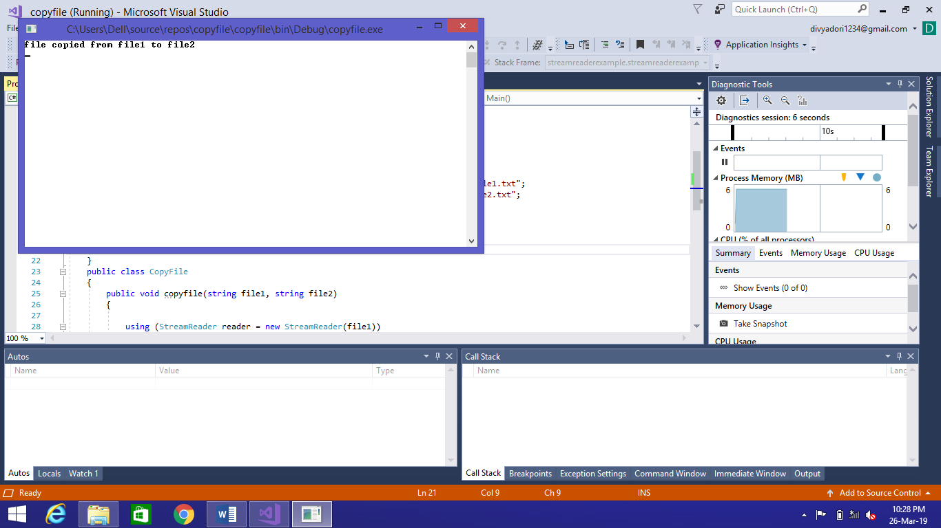

## Program 2

using System;

/*using System.Collections.Generic;

using System.Linq;

using System.Text;

using System.Threading.Tasks;

using System;*/

using System.IO;

namespace streamreaderexample

{

public class streamreaderexample

{

public static void Main()

{

StreamReader reader = new StreamReader("teststream.txt");

using (reader)

{

int lineNumber = 0;

string line = reader.ReadLine();

while (line != null)

{

lineNumber++;

Console.WriteLine("Line {0}: {1}", lineNumber, line);

line = reader.ReadLine();

}

String[] array1 = Directory.GetFiles(@"C:\Users\Dell\source\repos");

Console.WriteLine("files in the directory");

foreach(string name in array1)

{

Console.WriteLine(name);

}

Console.ReadLine();

}

}

}

}

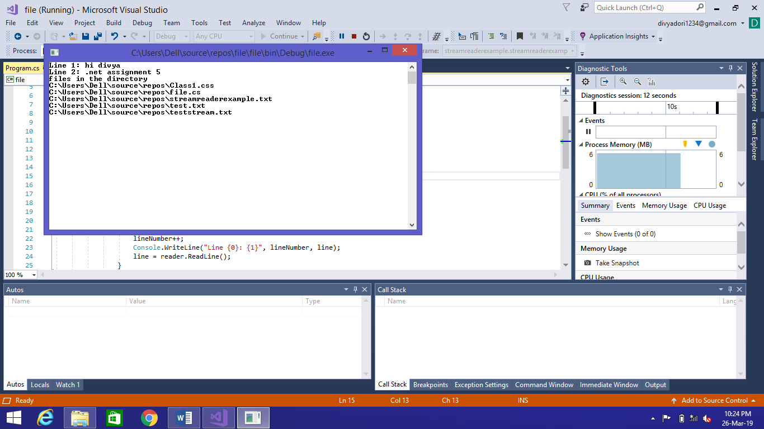

**Practical 6**

# AIM: Database Connectivity

## Program 1

Form 1

using System;

using System.Collections.Generic;

using System.ComponentModel;

using System.Data;

using System.Drawing;

using System.Linq;

using System.Text;

using System.Windows.Forms;

using System.Data.SqlClient;

namespace StudentRegistrationForm

{

public partial class Form1 : Form

{

public Form1()

{

InitializeComponent();

}

private void Gender_Click(object sender, EventArgs e)

{

}

private void Submit_Click(object sender, EventArgs e)

{

String gender;

if (rdoMale.Checked == true)

{

gender = "Male";

}

else

{

gender = "Female";

}

String source = @"Data Source=mycomputer\sqlexpress;Initial Catalog=DBstudent;Integrated Security=True;Pooling=False";

String select = "select count(*) from tblStudent;";

SqlConnection conn=new SqlConnection(source);

SqlCommand cmd=new SqlCommand(select,conn);

conn.Open();

int i=Convert.ToInt32(cmd.ExecuteScalar());

int pkStudent=i+1;

string insert="insert into tblStudent(pkStudent,fname,mname,lname,dob,Address,email,Father_name,Mother_name,Mobile_Number,Gender) values("+pkStudent+",'"+txtFirstName.Text+"','"+txtMiddleName.Text+"','"+txtLastName.Text+"','"+datepickDOB.Value.Date+"','"+txtAddress.Text+"','"+txtEmail.Text+"','"+txtFatherName.Text+"','"+txtMotherName.Text+"',"+txtMobNo.Text+",'"+gender+"')";

cmd= new SqlCommand(insert,conn);

int a= cmd.ExecuteNonQuery();

MessageBox.Show("You are Done");

InitializeComponent();

}

private void openFileDialog1_FileOk(object sender, CancelEventArgs e)

{

}

private void btnUpload_Click(object sender, EventArgs e)

{

openFileDialog1.Filter = "Jpg|*.jpg";

if (openFileDialog1.ShowDialog() == DialogResult.OK)

{

String imgPath;

imgPath = @"F:\16ce043\StudentRegistrationForm"+ openFileDialog1.SafeFileName;

imgStudent.Image = Image.FromFile(openFileDialog1.FileName);

}

}

private void Form1_Load(object sender, EventArgs e)

{

rdoMale.Checked = true;

}

}

}

FORM1.DESIGN

namespace StudentRegistrationForm

{

partial class Form1

{

/// <summary>

/// Required designer variable.

/// </summary>

private System.ComponentModel.IContainer components = null;

/// <summary>

/// Clean up any resources being used.

/// </summary>

/// <param name="disposing">true if managed resources should be disposed; otherwise, false.</param>

protected override void Dispose(bool disposing)

{

if (disposing && (components != null))

{

components.Dispose();

}

base.Dispose(disposing);

}

#region Windows Form Designer generated code

/// <summary>

/// Required method for Designer support - do not modify

/// the contents of this method with the code editor.

/// </summary>

private void InitializeComponent()

{

this.label1 = new System.Windows.Forms.Label();

this.txtFirstName = new System.Windows.Forms.TextBox();

this.txtMiddleName = new System.Windows.Forms.TextBox();

this.txtLastName = new System.Windows.Forms.TextBox();

this.Gender = new System.Windows.Forms.Label();

this.rdoMale = new System.Windows.Forms.RadioButton();

this.rdoFemale = new System.Windows.Forms.RadioButton();

this.label2 = new System.Windows.Forms.Label();

this.datepickDOB = new System.Windows.Forms.DateTimePicker();

this.imgStudent = new System.Windows.Forms.PictureBox();

this.btnUpload = new System.Windows.Forms.Button();

this.openFileDialog1 = new System.Windows.Forms.OpenFileDialog();

this.label3 = new System.Windows.Forms.Label();

this.txtMobNo = new System.Windows.Forms.TextBox();

this.label4 = new System.Windows.Forms.Label();

this.txtAddress = new System.Windows.Forms.TextBox();

this.email = new System.Windows.Forms.Label();

this.txtEmail = new System.Windows.Forms.TextBox();

this.label5 = new System.Windows.Forms.Label();

this.txtFatherName = new System.Windows.Forms.TextBox();

this.label6 = new System.Windows.Forms.Label();

this.txtMotherName = new System.Windows.Forms.TextBox();

this.btnSubmit = new System.Windows.Forms.Button();

((System.ComponentModel.ISupportInitialize)(this.imgStudent)).BeginInit();

this.SuspendLayout();

//

// label1

//

this.label1.AutoSize = true;

this.label1.Location = new System.Drawing.Point(84, 25);

this.label1.Name = "label1";

this.label1.Size = new System.Drawing.Size(35, 13);

this.label1.TabIndex = 0;

this.label1.Text = "Name";

//

// txtFirstName

//

this.txtFirstName.Location = new System.Drawing.Point(142, 25);

this.txtFirstName.Name = "txtFirstName";

this.txtFirstName.Size = new System.Drawing.Size(100, 20);

this.txtFirstName.TabIndex = 1;

//

// txtMiddleName

//

this.txtMiddleName.Location = new System.Drawing.Point(248, 25);

this.txtMiddleName.Name = "txtMiddleName";

this.txtMiddleName.Size = new System.Drawing.Size(100, 20);

this.txtMiddleName.TabIndex = 2;

//

// txtLastName

//

this.txtLastName.Location = new System.Drawing.Point(354, 25);

this.txtLastName.Name = "txtLastName";

this.txtLastName.Size = new System.Drawing.Size(100, 20);

this.txtLastName.TabIndex = 3;

//

// Gender

//

this.Gender.AutoSize = true;

this.Gender.Location = new System.Drawing.Point(77, 55);

this.Gender.Name = "Gender";

this.Gender.Size = new System.Drawing.Size(42, 13);

this.Gender.TabIndex = 4;

this.Gender.Text = "Gender";

this.Gender.Click += new System.EventHandler(this.Gender_Click);

//

// rdoMale

//

this.rdoMale.AutoSize = true;

this.rdoMale.Location = new System.Drawing.Point(142, 51);

this.rdoMale.Name = "rdoMale";

this.rdoMale.Size = new System.Drawing.Size(48, 17);

this.rdoMale.TabIndex = 5;

this.rdoMale.TabStop = true;

this.rdoMale.Text = "Male";

this.rdoMale.UseVisualStyleBackColor = true;

//

// rdoFemale

//

this.rdoFemale.AutoSize = true;

this.rdoFemale.Location = new System.Drawing.Point(213, 53);

this.rdoFemale.Name = "rdoFemale";

this.rdoFemale.Size = new System.Drawing.Size(59, 17);

this.rdoFemale.TabIndex = 6;

this.rdoFemale.TabStop = true;

this.rdoFemale.Text = "Female";

this.rdoFemale.UseVisualStyleBackColor = true;

//

// label2

//

this.label2.AutoSize = true;

this.label2.Location = new System.Drawing.Point(53, 85);

this.label2.Name = "label2";

this.label2.Size = new System.Drawing.Size(66, 13);

this.label2.TabIndex = 7;

this.label2.Text = "Date of Birth";

//

// datepickDOB

//

this.datepickDOB.Location = new System.Drawing.Point(142, 79);

this.datepickDOB.Name = "datepickDOB";

this.datepickDOB.Size = new System.Drawing.Size(200, 20);

this.datepickDOB.TabIndex = 8;

//

// imgStudent

//

this.imgStudent.BackColor = System.Drawing.SystemColors.ButtonHighlight;

this.imgStudent.Location = new System.Drawing.Point(665, 25);

this.imgStudent.Name = "imgStudent";

this.imgStudent.Size = new System.Drawing.Size(100, 103);

this.imgStudent.TabIndex = 9;

this.imgStudent.TabStop = false;

//

// btnUpload

//

this.btnUpload.Location = new System.Drawing.Point(665, 147);

this.btnUpload.Name = "btnUpload";

this.btnUpload.Size = new System.Drawing.Size(100, 23);

this.btnUpload.TabIndex = 10;

this.btnUpload.Text = "Upload";

this.btnUpload.UseVisualStyleBackColor = true;

this.btnUpload.Click += new System.EventHandler(this.btnUpload_Click);

//

// openFileDialog1

//

this.openFileDialog1.FileName = "openFileDialog1";

this.openFileDialog1.FileOk += new System.ComponentModel.CancelEventHandler(this.openFileDialog1_FileOk);

//

// label3

//

this.label3.AutoSize = true;

this.label3.Location = new System.Drawing.Point(41, 115);

this.label3.Name = "label3";

this.label3.Size = new System.Drawing.Size(78, 13);

this.label3.TabIndex = 11;

this.label3.Text = "Mobile Number";

//

// txtMobNo

//

this.txtMobNo.Location = new System.Drawing.Point(142, 115);

this.txtMobNo.Name = "txtMobNo";

this.txtMobNo.Size = new System.Drawing.Size(100, 20);

this.txtMobNo.TabIndex = 12;

//

// label4

//

this.label4.AutoSize = true;

this.label4.Location = new System.Drawing.Point(77, 145);

this.label4.Name = "label4";

this.label4.Size = new System.Drawing.Size(45, 13);

this.label4.TabIndex = 13;

this.label4.Text = "Address";

//

// txtAddress

//

this.txtAddress.Location = new System.Drawing.Point(142, 145);

this.txtAddress.Name = "txtAddress";

this.txtAddress.Size = new System.Drawing.Size(311, 20);

this.txtAddress.TabIndex = 14;

//

// email

//

this.email.AutoSize = true;

this.email.Location = new System.Drawing.Point(87, 175);

this.email.Name = "email";

this.email.Size = new System.Drawing.Size(32, 13);

this.email.TabIndex = 15;

this.email.Text = "Email";

//

// txtEmail

//

this.txtEmail.Location = new System.Drawing.Point(142, 175);

this.txtEmail.Name = "txtEmail";

this.txtEmail.Size = new System.Drawing.Size(100, 20);

this.txtEmail.TabIndex = 16;

//

// label5

//

this.label5.AutoSize = true;

this.label5.Location = new System.Drawing.Point(51, 205);

this.label5.Name = "label5";

this.label5.Size = new System.Drawing.Size(68, 13);

this.label5.TabIndex = 17;

this.label5.Text = "Father Name";

//

// txtFatherName

//

this.txtFatherName.Location = new System.Drawing.Point(142, 202);

this.txtFatherName.Name = "txtFatherName";

this.txtFatherName.Size = new System.Drawing.Size(100, 20);

this.txtFatherName.TabIndex = 18;

//

// label6

//

this.label6.AutoSize = true;

this.label6.Location = new System.Drawing.Point(51, 235);

this.label6.Name = "label6";

this.label6.Size = new System.Drawing.Size(71, 13);

this.label6.TabIndex = 19;

this.label6.Text = "Mother Name";

//

// txtMotherName

//

this.txtMotherName.Location = new System.Drawing.Point(142, 228);

this.txtMotherName.Name = "txtMotherName";

this.txtMotherName.Size = new System.Drawing.Size(100, 20);

this.txtMotherName.TabIndex = 20;

//

// btnSubmit

//

this.btnSubmit.Location = new System.Drawing.Point(665, 236);

this.btnSubmit.Name = "btnSubmit";

this.btnSubmit.Size = new System.Drawing.Size(75, 23);

this.btnSubmit.TabIndex = 21;

this.btnSubmit.Text = "Submit";

this.btnSubmit.UseVisualStyleBackColor = true;

this.btnSubmit.Click += new System.EventHandler(this.Submit_Click);

//

// Form1

//

this.AutoScaleDimensions = new System.Drawing.SizeF(6F, 13F);

this.AutoScaleMode = System.Windows.Forms.AutoScaleMode.Font;

this.BackColor = System.Drawing.SystemColors.ControlDarkDark;

this.ClientSize = new System.Drawing.Size(858, 261);

this.Controls.Add(this.btnSubmit);

this.Controls.Add(this.txtMotherName);

this.Controls.Add(this.label6);

this.Controls.Add(this.txtFatherName);

this.Controls.Add(this.label5);

this.Controls.Add(this.txtEmail);

this.Controls.Add(this.email);

this.Controls.Add(this.txtAddress);

this.Controls.Add(this.label4);

this.Controls.Add(this.txtMobNo);

this.Controls.Add(this.label3);

this.Controls.Add(this.btnUpload);

this.Controls.Add(this.imgStudent);

this.Controls.Add(this.datepickDOB);

this.Controls.Add(this.label2);

this.Controls.Add(this.rdoFemale);

this.Controls.Add(this.rdoMale);

this.Controls.Add(this.Gender);

this.Controls.Add(this.txtLastName);

this.Controls.Add(this.txtMiddleName);

this.Controls.Add(this.txtFirstName);

this.Controls.Add(this.label1);

this.Name = "Form1";

this.Text = "Form1";

this.Load += new System.EventHandler(this.Form1_Load);

((System.ComponentModel.ISupportInitialize)(this.imgStudent)).EndInit();

this.ResumeLayout(false);

this.PerformLayout();

}

#endregion

private System.Windows.Forms.Label label1;

private System.Windows.Forms.TextBox txtFirstName;

private System.Windows.Forms.TextBox txtMiddleName;

private System.Windows.Forms.TextBox txtLastName;

private System.Windows.Forms.Label Gender;

private System.Windows.Forms.RadioButton rdoMale;

private System.Windows.Forms.RadioButton rdoFemale;

private System.Windows.Forms.Label label2;

private System.Windows.Forms.DateTimePicker datepickDOB;

private System.Windows.Forms.PictureBox imgStudent;

private System.Windows.Forms.Button btnUpload;

private System.Windows.Forms.OpenFileDialog openFileDialog1;

private System.Windows.Forms.Label label3;

private System.Windows.Forms.TextBox txtMobNo;

private System.Windows.Forms.Label label4;

private System.Windows.Forms.TextBox txtAddress;

private System.Windows.Forms.Label email;

private System.Windows.Forms.TextBox txtEmail;

private System.Windows.Forms.Label label5;

private System.Windows.Forms.TextBox txtFatherName;

private System.Windows.Forms.Label label6;

private System.Windows.Forms.TextBox txtMotherName;

private System.Windows.Forms.Button btnSubmit;

}

}

using System;

using System.Collections.Generic;

using System.Linq;

using System.Windows.Forms;

namespace StudentRegistrationForm

{

static class Program

{

/// <summary>

/// The main entry point for the application.

/// </summary>

[STAThread]

static void Main()

{

Application.EnableVisualStyles();

Application.SetCompatibleTextRenderingDefault(false);

Application.Run(new Form1());

}

}

}

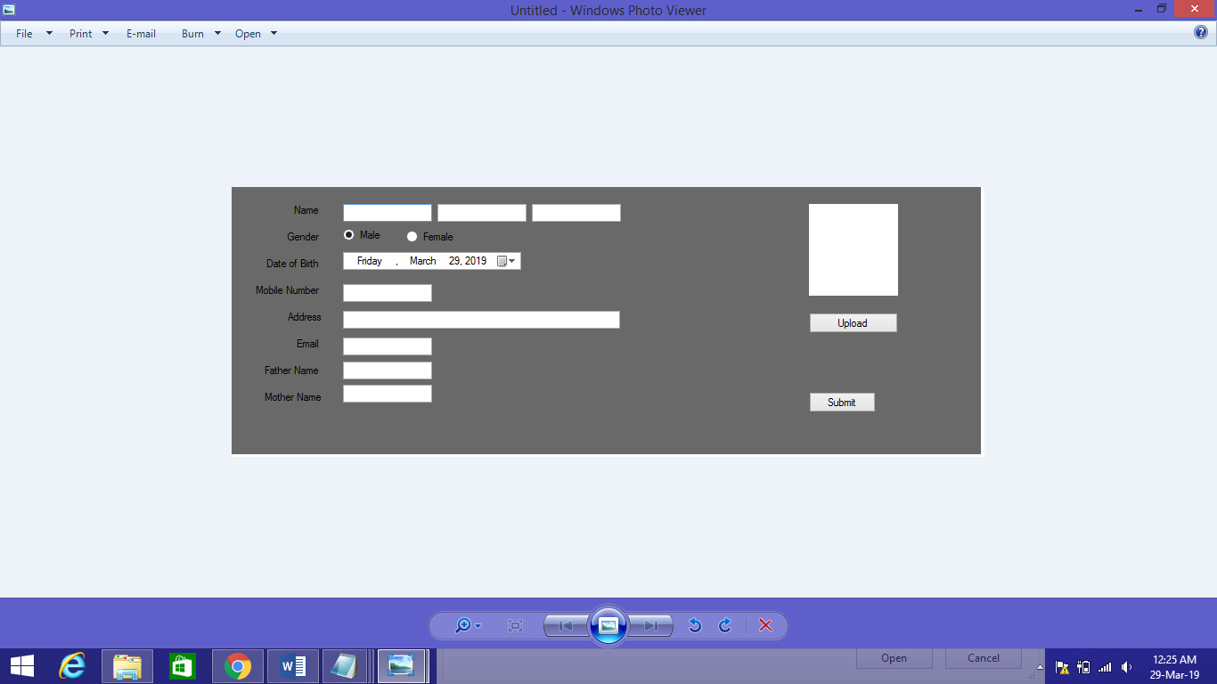

**Practical 7**

# AIM: form validation

## Program 1

Form 1

<%@ Page Language="C#" AutoEventWireup="true" CodeBehind="WebForm1.aspx.cs" Inherits="WebApplication1.WebForm1" %>

<!DOCTYPE html PUBLIC "-//W3C//DTD XHTML 1.0 Transitional//EN" "http://www.w3.org/TR/xhtml1/DTD/xhtml1-transitional.dtd">

<html xmlns="http://www.w3.org/1999/xhtml">

<head runat="server">

<title></title>

</head>

<body style="height: 19px">

<form id="form1" runat="server">

<p>

Name:<asp:TextBox ID="txtName" runat="server" ForeColor="Red"

ToolTip="Enter Your Name"></asp:TextBox>

<asp:RequiredFieldValidator ID="RequiredFieldValidator1" runat="server"

ControlToValidate="txtName" Display="Dynamic" ErrorMessage="Enter Your Name"

ForeColor="Red" ToolTip="Enter Your Name">*</asp:RequiredFieldValidator>

</p>

<p>

Email:<asp:TextBox ID="txtEmail" runat="server" ForeColor="Red"

ToolTip="Enter Your Email"></asp:TextBox>

<asp:RegularExpressionValidator ID="RegularExpressionValidator3" runat="server"

ControlToValidate="txtEmail" Display="Dynamic" ErrorMessage="Enter Valid Email"

ForeColor="Red" ToolTip="Enter Your Email"

ValidationExpression="\w+([-+.']\w+)*@\w+([-.]\w+)*\.\w+([-.]\w+)*">*</asp:RegularExpressionValidator>

</p>

<p>

Password:<asp:TextBox ID="txtPass" runat="server"></asp:TextBox>

&nbsp;&nbsp;&nbsp; Confirm Password:<asp:TextBox ID="txtConfirm" runat="server"></asp:TextBox>

<asp:CompareValidator ID="CompareValidator1" runat="server"

ControlToCompare="txtPass" ControlToValidate="txtConfirm"

ErrorMessage="Enter Same Password" ForeColor="Red"

ToolTip="Enter Same Password">*</asp:CompareValidator>

</p>

<p>

Semester:<asp:TextBox ID="txtSem" runat="server"></asp:TextBox>

<asp:RangeValidator ID="RangeValidator1" runat="server"

ControlToValidate="txtSem" ErrorMessage="Enter Semester between 1 to 8"

ForeColor="Red" MaximumValue="8" MinimumValue="1"

ToolTip="Enter Valid Semester" Type="Integer">*</asp:RangeValidator>

</p>

<p>

PhoneNo:<asp:TextBox ID="txtPhone" runat="server"></asp:TextBox>

<asp:RegularExpressionValidator ID="RegularExpressionValidator4" runat="server"

ControlToValidate="txtPhone" ErrorMessage="Enter Valid PhoneNo" ForeColor="Red"

ToolTip=" Enter Valid Phone Number" ValidationExpression="[0-9]{10}">*</asp:RegularExpressionValidator>

</p>

<asp:Button ID="btnSave" runat="server" Text="Save" />

<asp:ValidationSummary ID="ValidationSummary1" runat="server" />

</form>

</body>

</html>

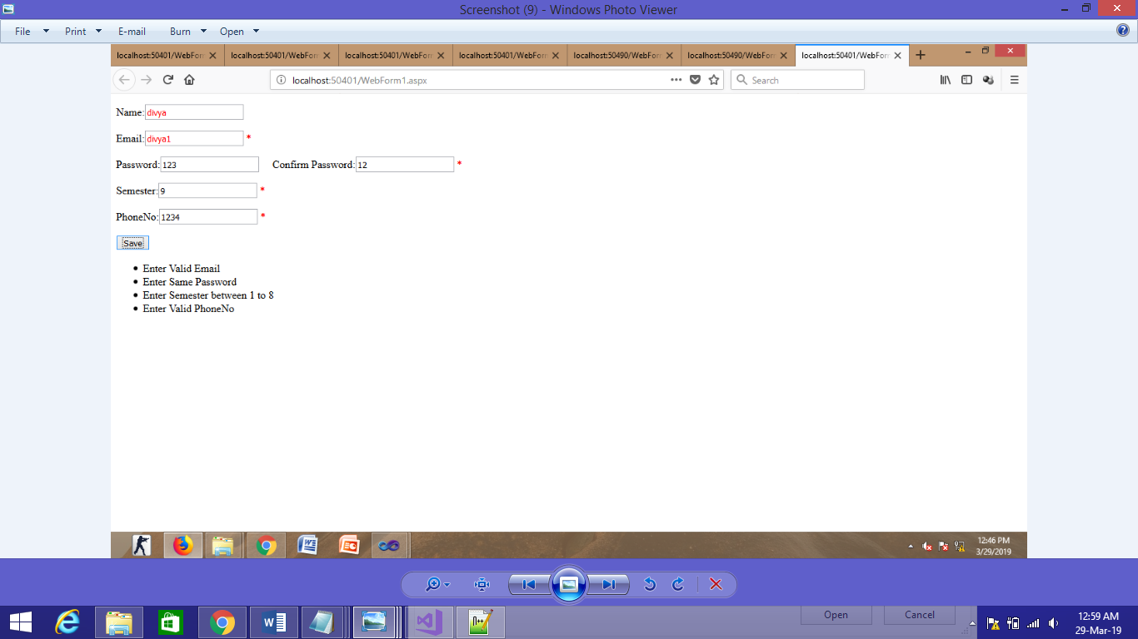

**Practical 8**

# AIM: master page

## Program 1

Web form 1.aspx

using System;

using System.Collections.Generic;

using System.Linq;

using System.Web;

using System.Web.UI;

using System.Web.UI.WebControls;

using System.Data.SqlClient;

namespace WebApplication5

{

public partial class WebForm2 : System.Web.UI.Page

{

protected void Page_Init(object sender, EventArgs e)

{

((Site1)Master).BtnSearch.Click += new EventHandler(btnSearch_Click);

}

protected void btnSearch_Click(object sender, EventArgs e)

{

GetData();

}

protected void Page_Load(object sender, EventArgs e)

{

}

void GetData()

{

string source = @"Data Source=.\SQLEXPRESS;AttachDbFilename=C:\Users\cecomp1\Documents\emp.mdf;Integrated Security=True;Connect Timeout=30;User Instance=True";

string select ="select * from tblStudent";

SqlConnection conn = new SqlConnection(source);

SqlCommand cmd = new SqlCommand(select, conn);

conn.Open();

SqlDataReader reader = cmd.ExecuteReader();

grdEmp.DataSource = reader;

grdEmp.DataBind();

conn.Close();

}

}

}

Webform 1.aspx

using System;

using System.Collections.Generic;

using System.Linq;

using System.Web;

using System.Web.UI;

using System.Web.UI.WebControls;

namespace WebApplication5

{

public partial class WebForm1 : System.Web.UI.Page

{

protected void Page_Load(object sender, EventArgs e)

{

}

protected void btnHeader_Click(object sender, EventArgs e)

{

((Site1)Master).LblHeader.Text = txtHeader.Text;

}

}

}

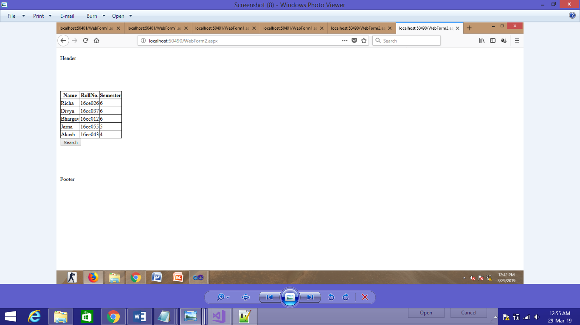

**Practical 8**

# AIM: web services

## Program 1

WEBFORM1.aspx

using System;

using System.Collections.Generic;

using System.Linq;

using System.Web;

using System.Web.UI;

using System.Web.UI.WebControls;

namespace divya

{

public partial class WebForm1 : System.Web.UI.Page

{

webservice.WebService1 cal = new webservice.WebService1();

protected void Page_Load(object sender, EventArgs e)

{

}

protected void btnadd_Click(object sender, EventArgs e)

{

lblresult.Text = cal.Add(Convert.ToInt16(txt1.Text), Convert.ToInt16(txt2.Text)).ToString();

}

protected void btnsub_Click1(object sender, EventArgs e)

{

lblresult.Text = cal.Sub(Convert.ToInt16(txt1.Text), Convert.ToInt16(txt2.Text)).ToString();

}

protected void btnmul_Click1(object sender, EventArgs e)

{

lblresult.Text = cal.Mul(Convert.ToInt16(txt1.Text), Convert.ToInt16(txt2.Text)).ToString();

}

protected void btndiv_Click1(object sender, EventArgs e)

{

lblresult.Text = cal.Div(Convert.ToInt16(txt1.Text), Convert.ToInt16(txt2.Text)).ToString();

}

}

}

WENSERVICES1.aspx

using System;

using System.Collections.Generic;

using System.Linq;

using System.Web;

using System.Web.Services;

namespace WebApplication1

{

/// <summary>

/// Summary description for WebService1

/// </summary>

[WebService(Namespace = "http://tempuri.org/")]

[WebServiceBinding(ConformsTo = WsiProfiles.BasicProfile1_1)]

[System.ComponentModel.ToolboxItem(false)]

// To allow this Web Service to be called from script, using ASP.NET AJAX, uncomment the following line.

// [System.Web.Script.Services.ScriptService]

public class WebService1 : System.Web.Services.WebService

{

[WebMethod]

public string HelloWorld()

{

return "Hello World";

}

[WebMethod]

public int Add(int a,int b)

{

return a+b;

}

[WebMethod]

public int Sub(int a, int b)

{

return a - b;

}

[WebMethod]

public int Mul(int a, int b)

{

return a * b;

}

[WebMethod]

public int Div(int a, int b)

{

return a / b;

}

}

}

OUTPUT:

